

**GROUP ASSIGNMENT**

CT036-3-3-IPPR

IMAGE PROCESSING, COMPUTER VISION

AND PATTERN RECOGNITION

Assignment Title:

**GLOVES DEFECT DETECTION SYSTEM**

Group Members:

|  |  |  |
| --- | --- | --- |
| **Name** | **ID** | **Intake Code** |
| Ng Eng Siong | TP055095 | APD3F2211CS(IS) |
| Wong Horng Woei | TP055241 | APD3F2211CS(IS) |
| Boey Shu Wei | TP053979 | APD3F2211CS |

Lecturer: Assoc. Prof. Dr. V. Sivakumar

Date Completed: 23 March 2023

Table of Contents

Contribution Matrix 1

Acknowledgement 2

1.0 Abstract 3

2.0 Introduction 4

3.0 Description and Justification of The Proposed Algorithm/Methods/Techniques 5

3.1 [rgb2hsv()] Conversion from RGB Images to HSV Color Space 5

3.2 [imbinarize()] Conversion from Grayscale Image to Binary 6

3.3 [strel()] Structured Element for Morphological Operations (Dilation/Erosion) 7

3.4 [imclose()] Morphological Closing Operation Algorithm 8

3.5 [bwareaopen()] Removing Small Objects from Binary Image 9

3.6 [imfill()] Fill Holes in Binary Image 10

3.7 [imdilate()] Dilating (Enlarge) White Regions in Binary Image 11

3.8 [medfilt2()] Image Filtering using Median Filter 11

3.9 [graythresh()] Otsu’s Thresholding method 12

3.10 [imcrop()] Extraction of Rectangular Region of Interest (ROI) from Image 13

3.11 [imclearborder()] Remove objects touching the image border 14

3.12 [imcomplement()] Inverting image 15

3.13 [regionprops()] The bounding boxes of the labeled regions 16

3.14 [bwconncomp()] Extract connected component 17

3.15 [imerode()] Morphological Erosion 18

3.16 [edge()] & [bwperim()] Edge detection 19

4.0 Experimental Results 20

4.1 (Latex Glove) Results by Ng Eng Siong (TP055095) 20

4.1.1 `Missing Finger` Defect 20

4.1.2 `Stained and Dirty` Defect 21

4.1.3 `Hole` Defect 22

4.2 (Cloth Glove) Results by Wong Horng Woei (TP055241) 23

4.2.1 `Open Seam` Defect 23

4.2.2 `Unravelled Seam` Defect 24

4.2.3 `Tearing` Defect 25

4.3 (Foam Glove) Results by Boey Shu Wei (TP053979) 26

4.3.1 `Cutting` Defect 26

4.3.2 `Small Wrist Thorn Cut` Defect 26

4.3.3 `Wrist Tearing` Defect 27

5.0 Description and Discussion on The Obtained Results 28

5.1 Discussion by Ng Eng Siong (TP055095) 28

5.2 Discussion by Wong Horng Woei (TP055241 30

5.3 Discussion by Boey Shu Wei (TP053979) 32

6.0 Critical Comments, Analysis and Future Work Direction 33

7.0 Conclusion 34

References 35

# Contribution Matrix

|  |  |  |  |
| --- | --- | --- | --- |
| Workload | Ng Eng Siong  (TP055095) | Wong Horng Woei  (TP055241) | Boey Shu Wei  (TP053979) |
| Abstract | - | - | 100% |
| Introduction | - | 100% | - |
| Description and Justification of The Proposed Algorithm / Methods / Techniques | 33.33% | 33.33% | 33.33% |
| Experimental Results | 33.33% | 33.33% | 33.33% |
| Description and Discussion on The Obtained Results | 33.33% | 33.33% | 33.33% |
| Critical Comments, Analysis and Future Work Direction | 33.33% | 33.33% | 33.33% |
| Conclusion | 100% | - | - |

All members contributed evenly.

# Acknowledgement

We would like to express our sincere gratitude and appreciation to Assoc. Prof. Dr. V. Sivakumar, our lecturer, for providing us with the opportunity to work on this project and for his guidance and support throughout the course of this project. His expertise and knowledge in the field of image processing, computer vision, and pattern recognition have been invaluable in helping us develop the Gloves Defect Detection (GDD) system.

Furthermore, we would like to thank our fellow group members for their contributions and collaboration during the project. Their insights and feedback have helped us refine and improve our ideas and implementations.

Lastly, we would like to express our appreciation to our families and friends for their unwavering support and encouragement throughout our academic journey. Their support has been a source of motivation and inspiration for us to strive for excellence in our work.

# 1.0 Abstract

This project aims to develop a software artifact that can automatically detect defects in gloves using image processing and computer vision techniques. The system must be robust enough to identify different defects in at least three types of gloves, and a GUI must be developed to show the types of defects. The project requires the survey and selection of candidate techniques, and their justification, including any libraries and data used. The system should not be sensitive to environmental changes, and Haar Cascade, Tensorflow, and pattern matching methods should not be used. The deliverables include a supporting document that reflects on the methodologies and implementation tasks applied in the development of the application, as well as a description and justification of the theoretical information about the image processing and computer vision algorithms used. The testing results using various test images will be provided, including critical analysis for cases of images that fail. By completing this project, valuable practical knowledge and experience will be gained in image processing, computer vision, and pattern recognition, as well as the ability to design and implement a software artifact that processes images for a given problem domain using appropriate methods.

# 2.0 Introduction

Image processing, computer vision, and pattern recognition techniques have become increasingly important in the field of defect detection as mentioned by (Ren, Fang, Yan, & Wu, 2021). The aim of this group assignment is to provide a practical understanding of these techniques through the development of a gloves defect detection system. This project will require careful selection and evaluation of candidate techniques and design to implement a gloves defect detection (GDD) system and test the system to evaluate the accuracy of the proposed techniques.

The challenge of this project is to develop a system that can accurately identify various types of defects in gloves, while being robust enough to account for different environmental conditions.

The final deliverables for this project include a GDD system that can detect defects in at least three types of gloves, identify a minimum of three defects for each group member, and display the types of defects through a user-friendly GUI. A supporting document will need to be produced which reflects on the methodologies and implementation tasks applied in the development of the application.

# 3.0 Description and Justification of The Proposed Algorithm/Methods/Techniques

## 3.1 [rgb2hsv()] Conversion from RGB Images to HSV Color Space

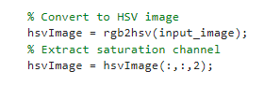

Figure : rgb2hsv algorithm code snippet

rgb2hsv() is used to convert the input RGB image to the HSV color space (MathWorks, rgb2hsv, 2023). The saturation channel (the second channel) of the resulting HSV image is then extracted and thresholded to create a binary image of the glove region.

The reason for converting the input RGB image to the HSV color space is that the HSV color space separates the color information into hue, saturation, and value channels, which makes it easier to isolate the saturation information (Parekh, 2021), which is the channel that is most likely to contain the information about the color of the glove.

To sum it up, the rgb2hsv() function is used in this code to facilitate the isolation of the saturation information, which is then used to extract the glove region and count the number of fingers in the image.

## 3.2 [imbinarize()] Conversion from Grayscale Image to Binary

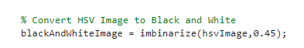

Figure : imbinarize() algorithm code snippet

In the code snippet, the imbinarize() function is used to convert the saturation channel of the HSV image into a binary image of the glove region.

The imbinarize() function is a thresholding function that converts grayscale or RGB images into binary images by assigning 1 to pixels with intensities above a certain threshold and 0 to pixels with intensities below the threshold (MathWorks, imbinarize, 2023). In the code, a threshold value of 0.45 is used to convert the saturation channel of the HSV image to a binary image. The binary image obtained by imbinarize() is then used to extract the glove region. The pixels with a value of 1 in the binary image correspond to the glove region, and those with a value of 0 correspond to the background.

By converting the saturation channel of the HSV image into a binary image using imbinarize(), the saturation information is simplified into a binary form that is easier to process and analyze. This simplification makes it easier to apply morphological operations to the binary image and extract the glove region accurately.

## 3.3 [strel()] Structured Element for Morphological Operations (Dilation/Erosion)

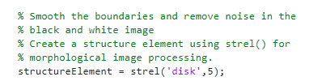

Figure : Example 1 of Structured Element code snippet

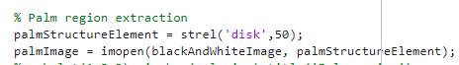

Figure : Example 2 of Structured Element code snippet

In the code snippet, the strel() function is used to create a structuring element that is used in morphological image processing operations such as dilation, erosion, opening, and closing.

The strel() function is used to create a structuring element of a specific shape and size that can be used to perform morphological operations on an image (MathWorks, strel, 2023). In this code, the strel() function is used to create a disk-shaped structuring element with a radius of 5 pixels for smoothening the boundaries of the binary image and removing noise, and a larger disk-shaped structuring element with a radius of 50 pixels for extracting the palm region. The smaller structuring element is used with the imclose() function to close any small holes or gaps in the binary image and smooth the boundaries of the glove region. The larger structuring element is used with the imopen() function to extract the palm region by removing all other parts of the image except the region enclosed by the larger structuring element.

To sum up, the strel() function is used in this code to create structuring elements of different sizes and shapes that are used to perform morphological image processing operations on the binary image (Parekh, 2021). These operations are used to smooth the boundaries of the glove region, remove noise, and extract the palm region, which are essential steps in accurately counting the number of fingers in the input image.

## 3.4 [imclose()] Morphological Closing Operation Algorithm

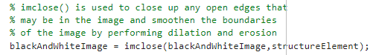

Figure : imclose() algorithm code snippet

In the code snippet, the imclose() function is used to smooth the boundaries of the binary image obtained after thresholding the saturation channel of the input image in the glove region. The purpose of smoothing the boundaries is to remove any small gaps or holes that might be present in the binary image, which can cause errors in the subsequent processing steps.

The imclose() function takes two input arguments: the input binary image and the structuring element used for the closing operation (MathWorks, imclose, 2023). In the code, a disk-shaped structuring element of radius 5 is used, which is created using the strel() function. The disk-shaped structuring element is a commonly used structuring element in morphological image processing and is used here to perform dilation and erosion operations on the binary image.

The dilation operation expands the boundaries of the foreground pixels in the binary image, while the erosion operation shrinks the boundaries of the foreground pixels (Parekh, 2021). The combination of dilation and erosion operations in imclose() effectively fills in small gaps or holes in the binary image and smooths the boundaries of the glove region.

## 3.5 [bwareaopen()] Removing Small Objects from Binary Image

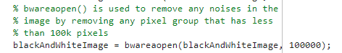

Figure : bwareaopen() algorithm code snippet

In the code, the bwareaopen() function is used to remove small connected components (objects) in the binary image (MathWorks, bwareaopen, 2023) obtained after thresholding the saturation channel of the HSV image.

The bwareaopen() function removes objects whose area is smaller than a specified size threshold (MathWorks, bwareaopen, 2023). In this code, the threshold is set to 100,000 pixels. This means that any connected component in the binary image with an area of less than 100,000 pixels will be removed. The purpose of using bwareaopen() is to remove small objects (such as noise) in the binary image that are not part of the glove region. This helps to ensure that the binary image only contains the glove region and not any other unwanted objects.

To sum up, the bwareaopen() function is used in this code to remove small objects in the binary image obtained after thresholding the saturation channel of the HSV image, and to ensure that the final binary image only contains the glove region.

## 3.6 [imfill()] Fill Holes in Binary Image

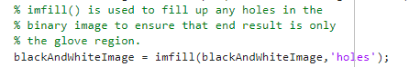

Figure : imfill() algorithm code snippet

In the code snippet, the imfill() function is used to fill any holes that might be present inside the binary image obtained after thresholding the saturation channel of the input image in the glove region. The purpose of filling these holes is to ensure that the result only contains the glove region and does not have any unwanted holes or gaps.

The imfill() function takes two input arguments: the input binary image and the method used for filling the holes (MathWorks, imfill, 2023). In the code, the 'holes' method is used to fill the holes in the binary image. The 'holes' method identifies the holes inside a binary object and fills them in, so that the object becomes solid.

The imfill() function is often used in image processing tasks to fill in holes in binary objects or to create filled-in versions of objects (Parekh, 2021). In the code, it is used to ensure that the binary image obtained after thresholding the saturation channel of the input image only contains the glove region and does not have any unwanted holes or gaps, which is essential for accurately counting the number of fingers in the input image.

## 3.7 [imdilate()] Dilating (Enlarge) White Regions in Binary Image

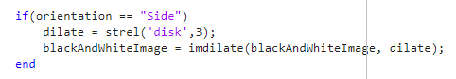

Figure : imdilate algorithm code snippet used for `Side` orientation

In the code snippet, the imdilate() function is used to perform image dilation on the binary image blackAndWhiteImage when the orientation is not a palm. The image dilation process is done to make the edges of the finger region more connected and prominent (MathWorks, imdilate, 2023). In this case, a disk-shaped structuring element with a radius of 3 pixels is used to perform the dilation operation, which expands the boundaries of the white pixels in the image. This helps to fill in any gaps between the white pixels in the image, which can help to make the finger region more easily distinguishable from the glove region.

The dilation operation can also help to reduce the effects of noise in the image, which can lead to false detections or inaccuracies in the finger detection process (Parekh, 2021). To sum it up, the imdilate() function is used to improve the accuracy and robustness of the finger detection algorithm when the orientation is not a palm.

## 3.8 [medfilt2()] Image Filtering using Median Filter

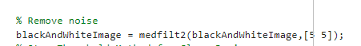

Figure : medfilt2() algorithm code snippet

medfilt2() is a 2-D median filtering function that removes noise from an image by replacing each pixel value with the median value in its neighbourhood (MathWorks, medfilt2, 2023). Median filtering is a non-linear filtering technique that is particularly effective at removing salt-and-pepper noise, which is a type of noise that manifests as white and black pixels scattered throughout an image.

In the code snippet, medfilt2() is used after binarizing the image using a threshold to remove the noise from the image. Since the noise in the image can cause erroneous pixel values, which can affect the result of the finger defect detection algorithm, medfilt2() is used to remove the noise by replacing the pixel value with the median value in its neighbourhood. By doing so, it reduces the chances of false detection and improves the accuracy of the finger defect detection algorithm (Parekh, 2021).

## 3.9 [graythresh()] Otsu’s Thresholding method

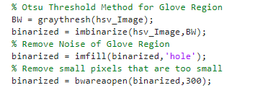

Figure : Usage of graytresh() algorithm code snippet

In the code snippet, graythresh() is used to apply Otsu's thresholding method on the saturation channel of the input image in order to isolate the glove region. Otsu's thresholding method is used to automatically determine the threshold value for image segmentation (MathWorks, graytresh, 2023). It is based on the histogram of the input image and tries to find a threshold that minimizes the variance between two classes of pixels, i.e., the foreground and the background (Parekh, 2021).

In this code, the graythresh() function takes the saturation channel of the input image as its input, and returns a threshold value that is used to binarize the saturation channel using imbinarize(). This threshold value is automatically determined based on the intensity histogram of the saturation channel.

After binarizing the saturation channel using the threshold obtained from graythresh(), the glove region is obtained by filling the holes in the binary image using imfill(). Finally, small objects in the binary image are removed using bwareaopen() to obtain a clean binary mask for the glove region.

## 3.10 [imcrop()] Extraction of Rectangular Region of Interest (ROI) from Image

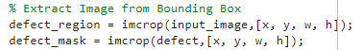

Figure : imcrop() algorithm code snippet

imcrop() function in MATLAB is used to crop an image (MathWorks, imcrop, 2023). It allows the user to select a rectangular portion of an image by dragging the mouse over the desired region, and then returns an output image containing only that portion of the original image.

In the given code, imcrop() function is used to extract the ROI from the original image (Parekh, 2021). The input to imcrop() function is the original image and the coordinates of the bounding box of the defect region, which was obtained using regionprops() function earlier in the code. regionprops() is used to extract the centroids of each connected component in the binary image.

The purpose of using imcrop() function here is to extract the region of the defect from the input image so that it can be further processed for detecting the skin coverage. Once the defect region is obtained using imcrop(), it is then resized to have the same size as the input image, and then used to create a binary mask based on skin color cluster, which is then used to segment the image into regions for detecting the skin coverage.

## 3.11 [imclearborder()] Remove objects touching the image border

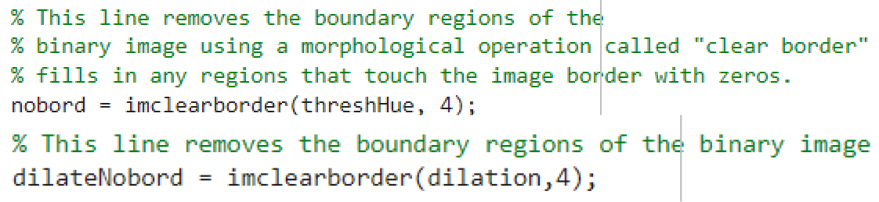

In MATLAB, the imclearborder() function is used to clear objects that touch the border of an image (Parekh, 2021). Specifically, it removes all connected components (objects) that are touching the border pixels of an image (Parekh, 2021).

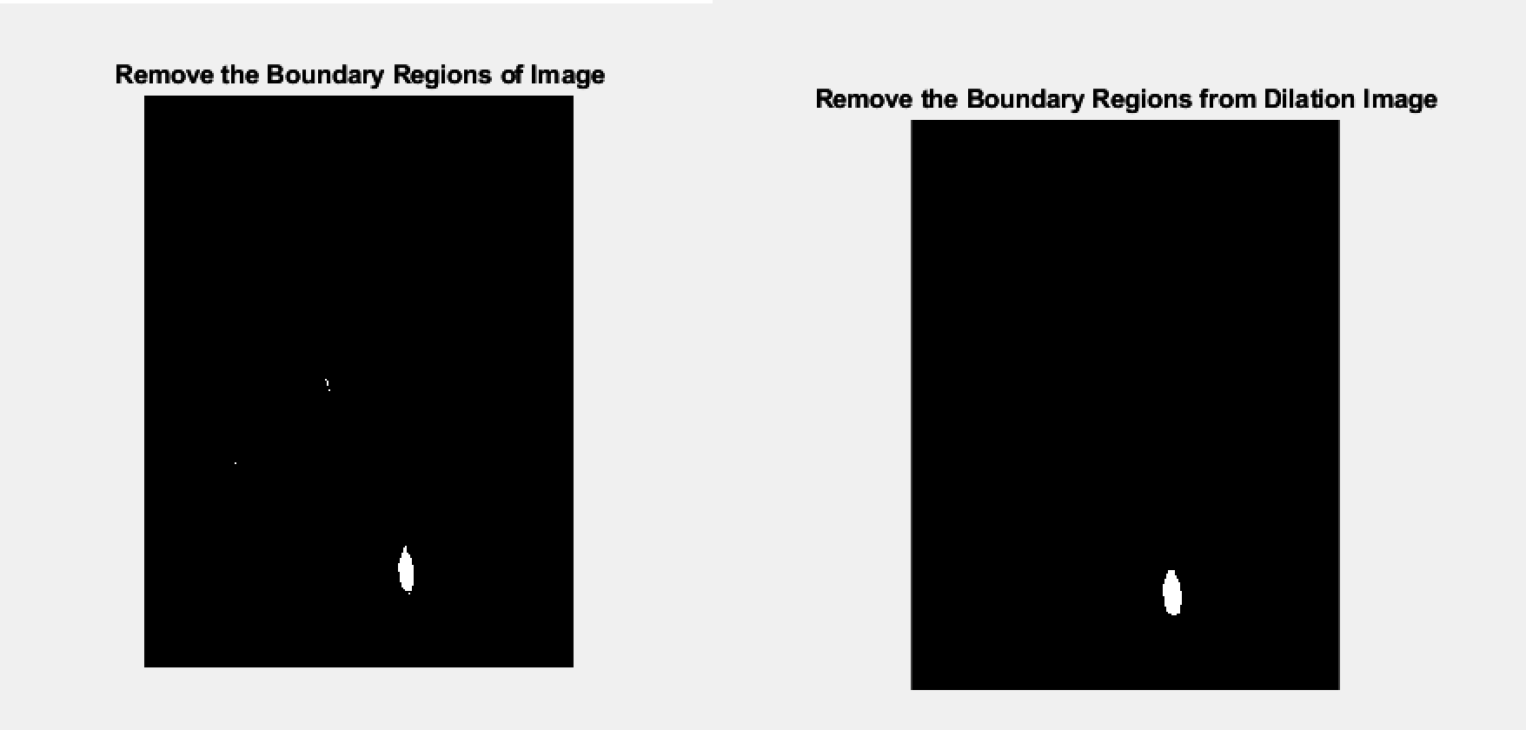

Figure : Results of imclearborder() used in Cloth Glove Defect Detection.

The imclearborder() algorithm is used in this code to remove the boundary regions of the binary image. When performing image processing tasks, it is often useful to remove or ignore objects that are touching the image boundary. In this case, it is likely that objects that touch the image boundary are not fully captured in the image and can be incomplete or noisy. Thus, removing the boundary regions can improve the accuracy of subsequent processing steps, such as region labeling or bounding box extraction.

Additionally, this code uses imclearborder() twice. The first time it removes the boundary regions from the binary image obtained from thresholding the hue channel. The second time, it removes the boundary regions from the result of applying morphological dilation to the binary image. This is done to further remove any noisy or incomplete regions that may be touching the image boundary after the dilation operation.

## 3.12 [imcomplement()] Inverting image



The imcomplement() function in MATLAB is used to obtain the complement of a binary or grayscale image (MathWorks, 2023a). The complement of an image is obtained by subtracting each pixel value from the maximum possible value for that data type (Parekh, 2021).

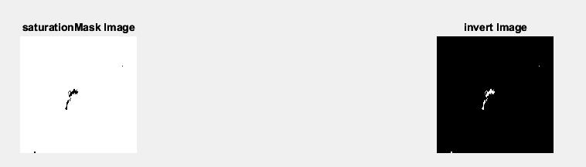

Figure : Results of imcomplement() used in Cloth Glove Defect Detection.

In the provided code, imcomplement() function is used to invert the binary mask generated to segment out pixels with low or high saturation. The goal of the saturation mask is to segment out regions in the image that have moderate saturation levels and remove the regions with low or high saturation levels. This is done by creating two binary masks for low and high saturation levels, respectively, and then combining them using an OR operation. However, the resulting binary mask includes the regions with moderate saturation levels, which are the ones we want to keep. Therefore, to keep the regions with moderate saturation levels, the imcomplement() function is used to invert the binary mask and keep only the regions with moderate saturation levels.

## 3.13 [regionprops()] The bounding boxes of the labeled regions

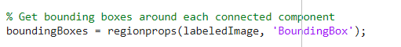

The regionprops() function is a MATLAB built-in function that is used to extract properties of connected regions in a binary image or label matrix (Parekh, 2021). It takes as input a binary image or label matrix and returns a structure array containing a variety of region properties, such as area, centroid, bounding box, and orientation (Parekh, 2021).

The regionprops() function is used in the given code to extract the bounding boxes of the connected regions in the final binary mask. After preprocessing the input image to create a binary mask that segments out regions with moderate saturation and removes unwanted regions near the image border, the regionprops() function is called with the input argument labeledImage, which is the label matrix obtained from the binary mask using the bwlabel() function. The 'BoundingBox' option is used as the second argument to the regionprops() function to compute the bounding boxes of the connected regions in the binary mask.

The resulting boundingBoxes structure array contains the bounding box information for each connected region, including the (x, y) coordinates of the top-left corner of the bounding box, as well as its width and height. This information is then used to draw a rectangle around each connected region in the original input image using the rectangle() function.

By using regionprops() to extract the bounding boxes of the connected regions in the binary mask, the code is able to identify and locate the regions of interest in the input image, which can be used for further processing or analysis.

## 3.14 [bwconncomp()] Extract connected component

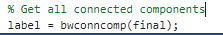

Figure : bwconncomp() function

This is a function to extract each connected groups of pixels and store each group in a structure, it only works with binary picture which only contain 0 and 1 intensity value. In the assignment, we use it to extract the defections’ area after some subtraction. Then, based on the defection, we perform different analysis on those components, like largest group of pixels. This is also useful because it allows us to locate those groups of pixels location, and then plot a red box around it (MathWorks, bwconncomp, n.d.).

## 3.15 [imerode()] Morphological Erosion

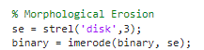

Figure : imerode function

This is a function for morphological erosion, it involves using a structured element like square, disk, diamond, etc., compare and replace pixel by pixel. This function can be used in many purposes. In this assignment, it is used for removing noise with larger dots, shrinkage, manifest holes, and clearer separation (Izmiran, n.d.).

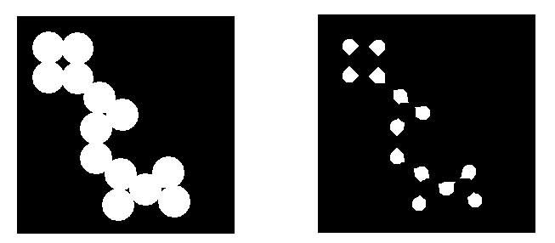

Figure : Before and after erosion (Izmiran, n.d.)

## 3.16 [edge()] & [bwperim()] Edge detection

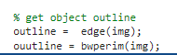

In MATLAB, both functions are used for edge detection. However, bwperim() marks the pixels on the boundaries of the object, and returns a binary image of 1 and 0 density only (MathWorks, bwperim, n.d.)

In the other hand, edge() gives more flexibility and is a more general purpose function. It highlights high gradient magnitude as edges. The function also allows to apply with more complex logics and algorithms into the parameter for different scenarios. The result can be in binary or grayscale image (MathWorks, edge, n.d.).

# 4.0 Experimental Results

## 4.1 (Latex Glove) Results by Ng Eng Siong (TP055095)

### 4.1.1 `Missing Finger` Defect

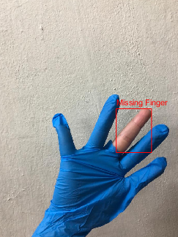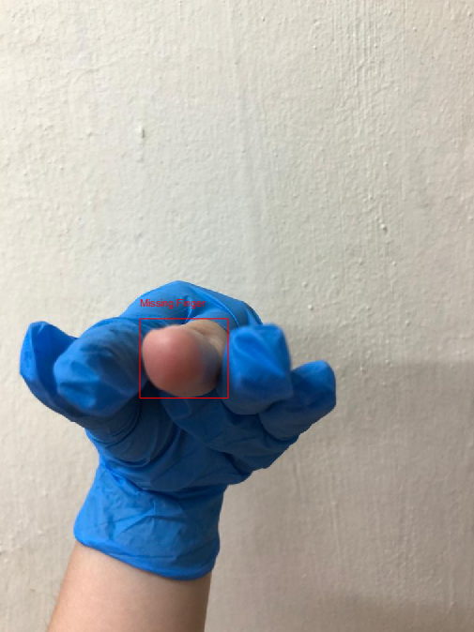

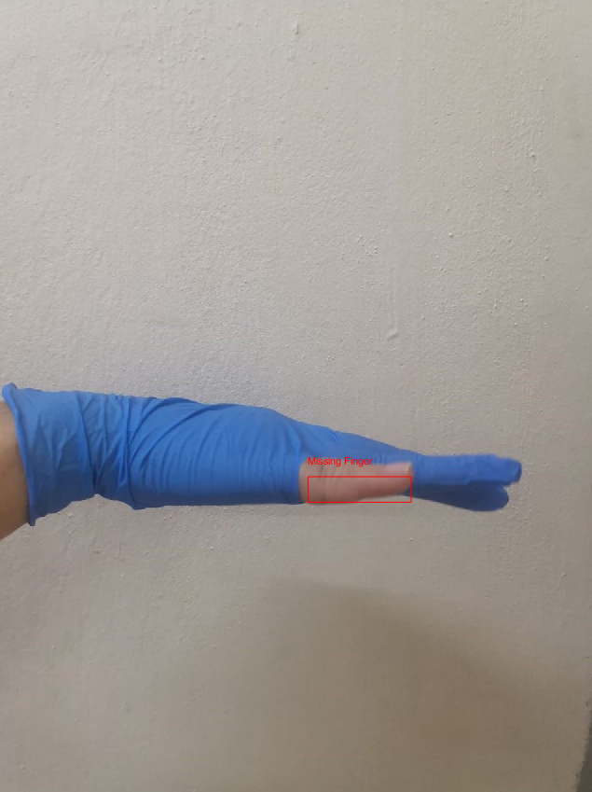

Figure : Missing Finger Glove Defect

### 4.1.2 `Stained and Dirty` Defect

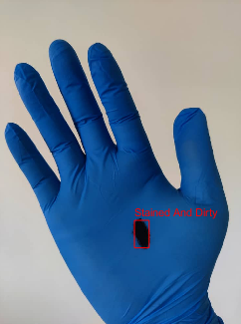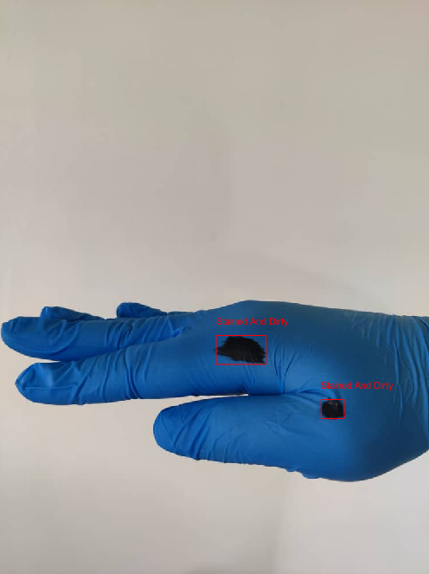

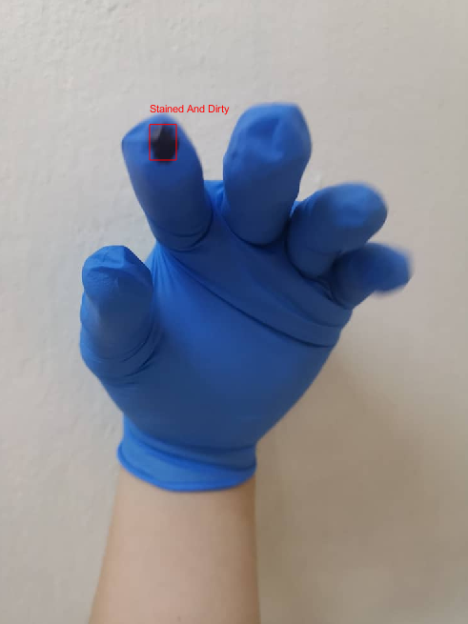

Figure : Stained and Dirty Glove Defect

### 4.1.3 `Hole` Defect

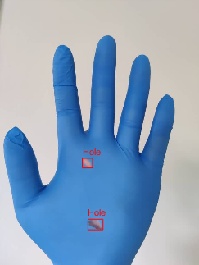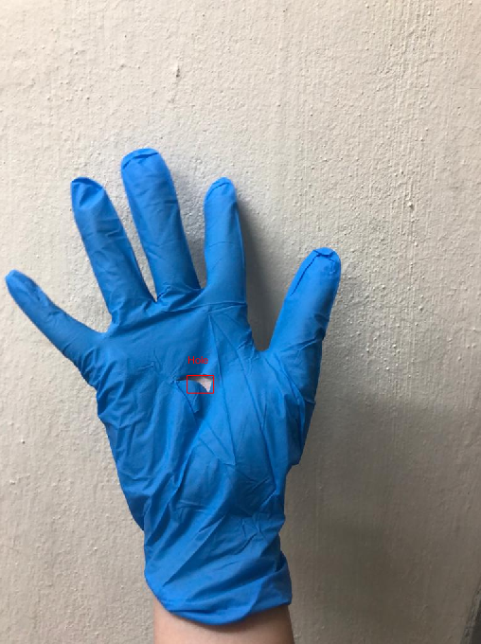

Figure : Hole Defect

## 4.2 (Cloth Glove) Results by Wong Horng Woei (TP055241)

### 4.2.1 `Open Seam` Defect

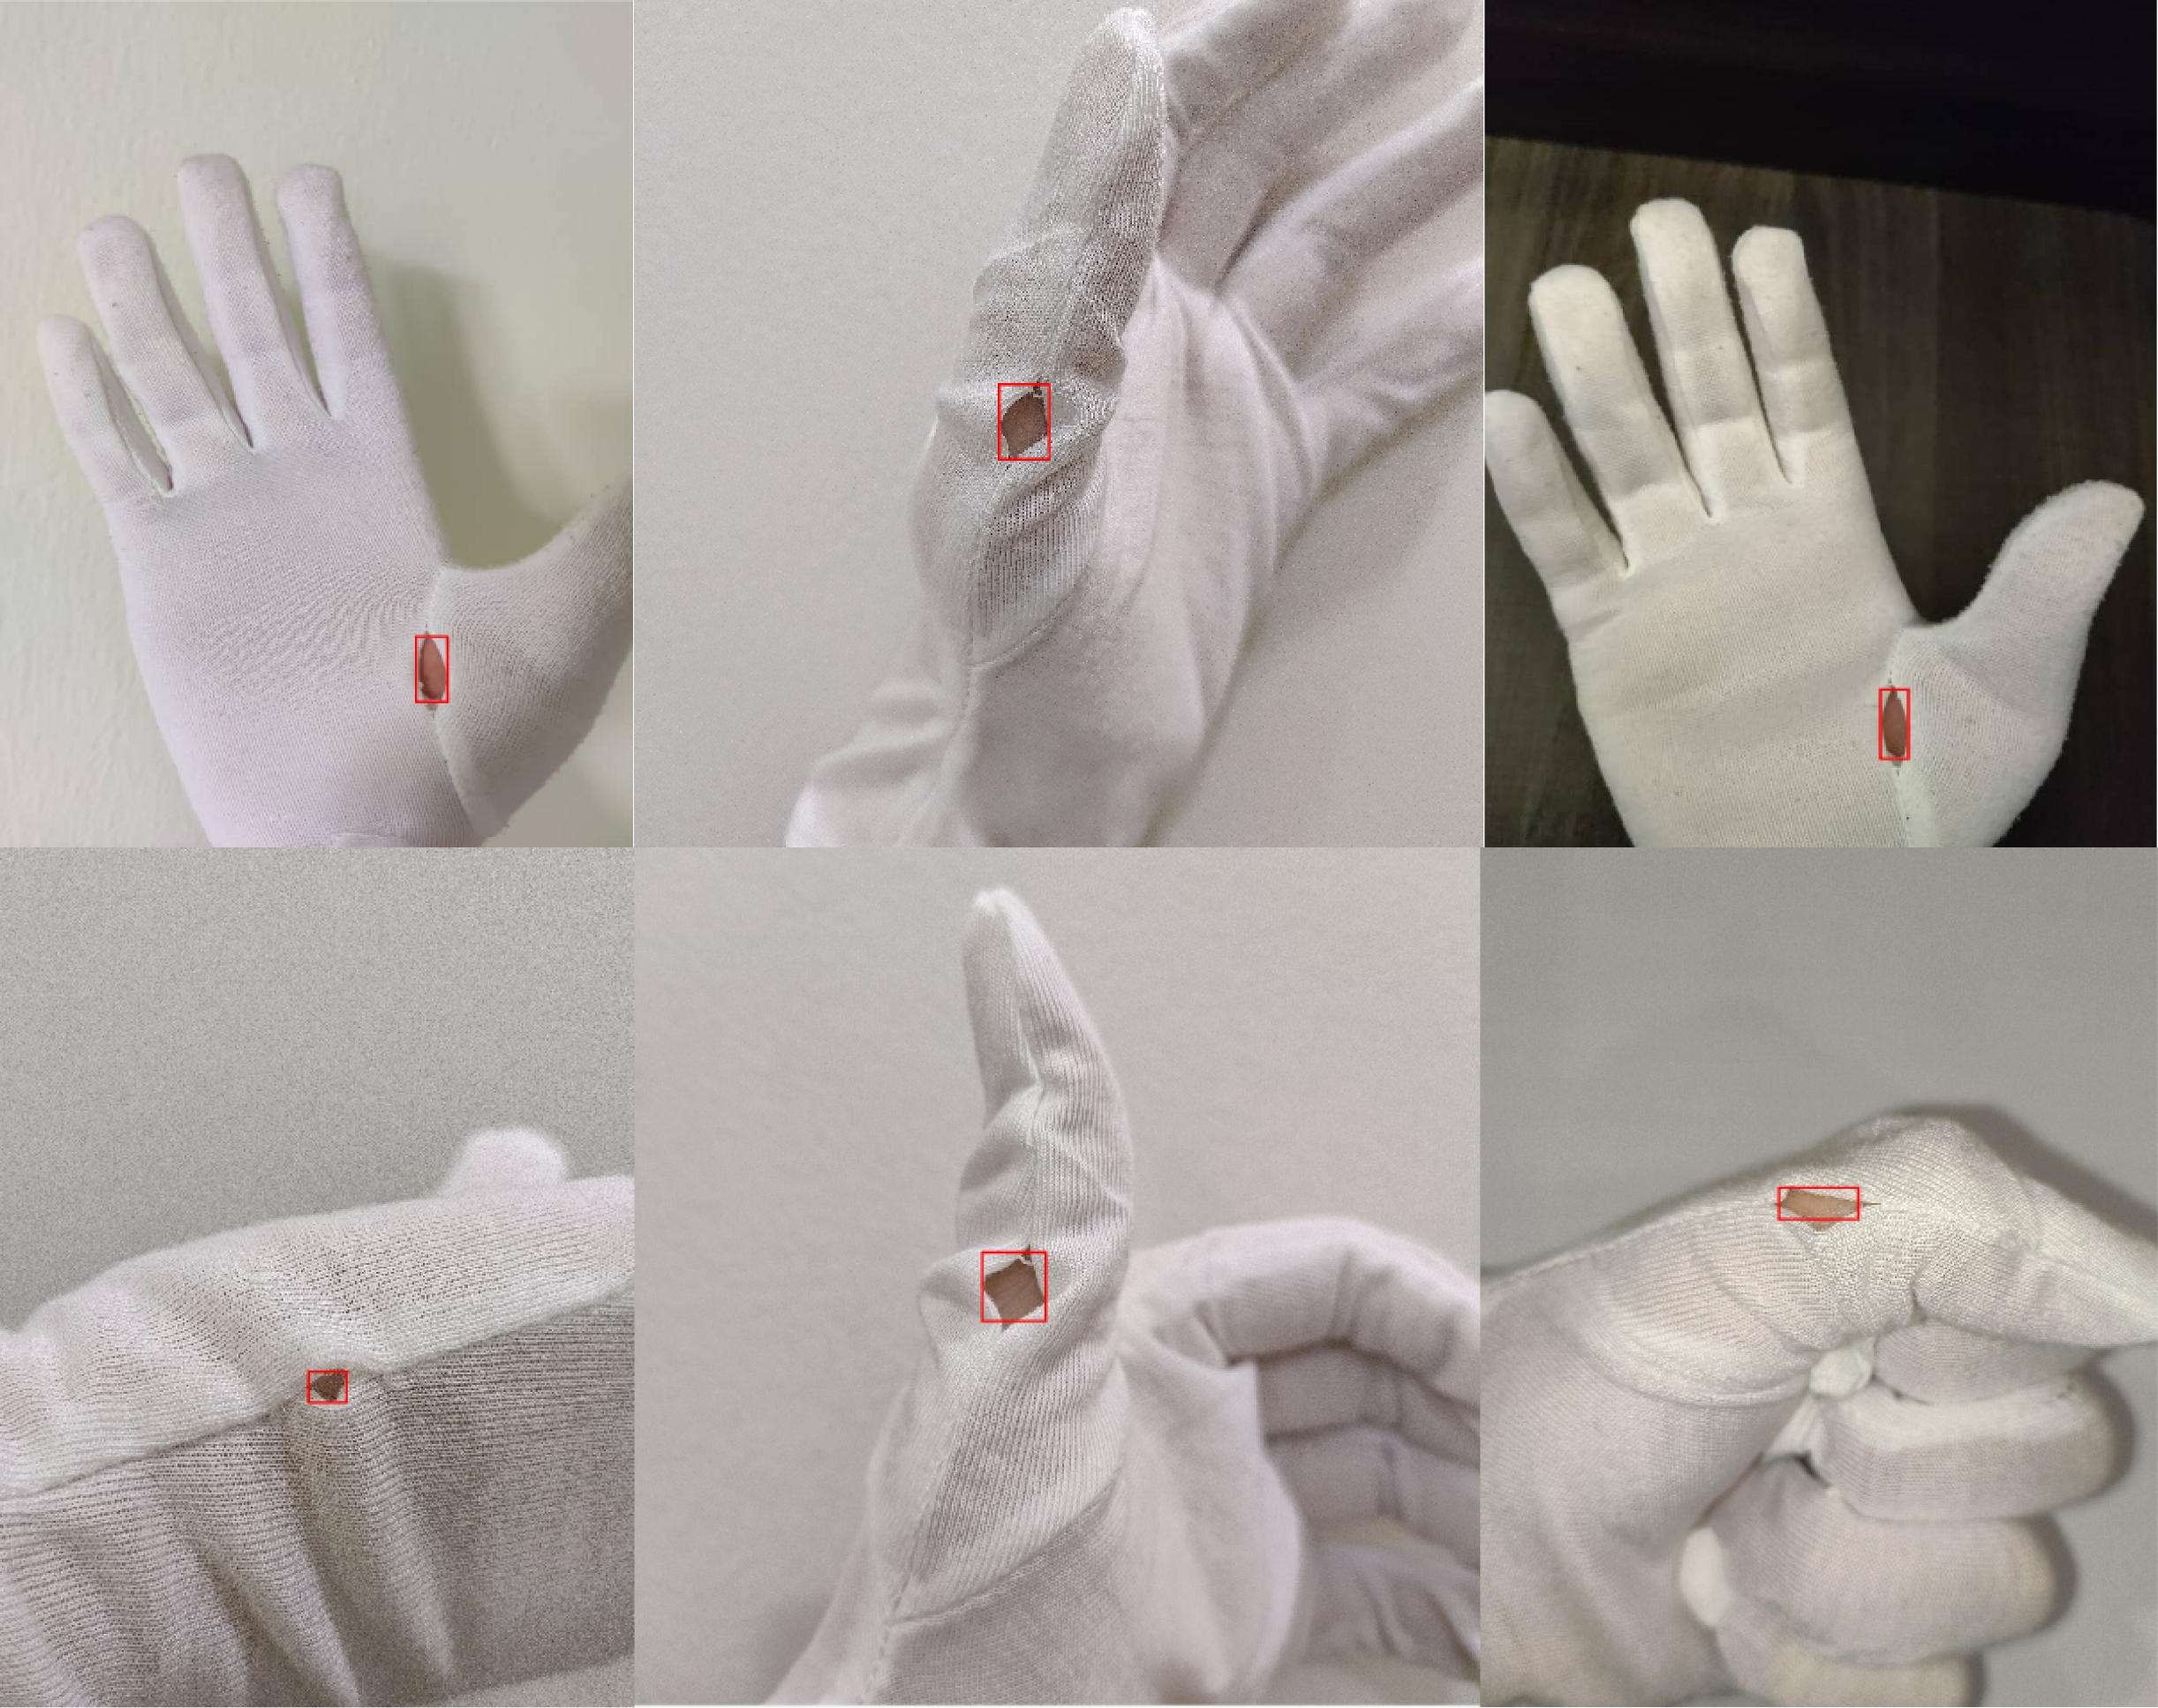

Figure : Cloth Glove Open Seam Defect Detection.

### 4.2.2 `Unravelled Seam` Defect

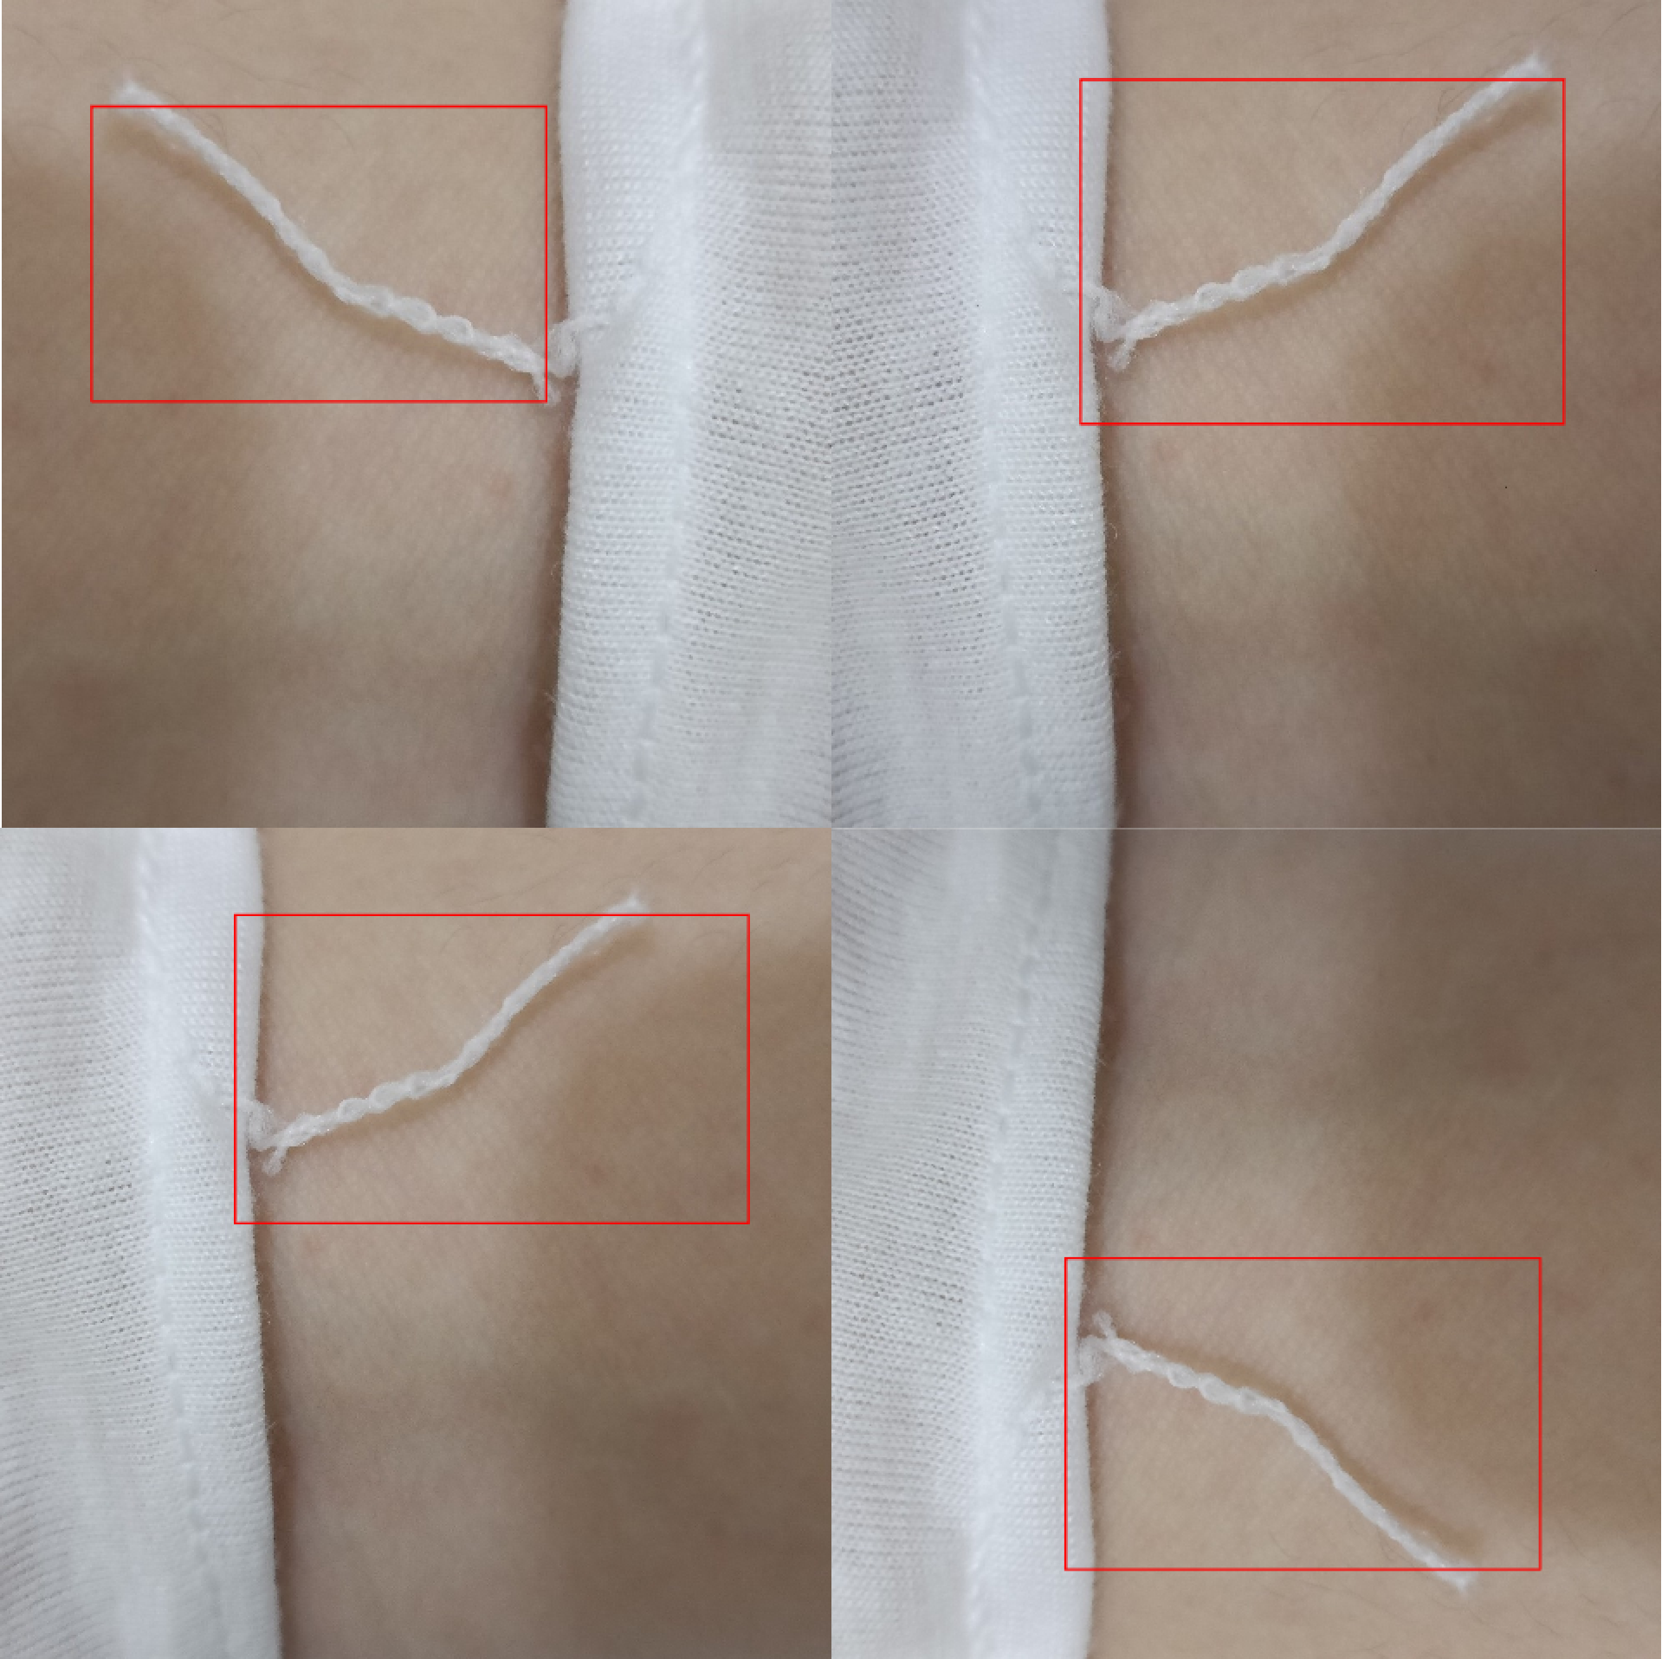

Figure : Cloth Glove Unravelled Seam Defect Detection.

### 4.2.3 `Tearing` Defect

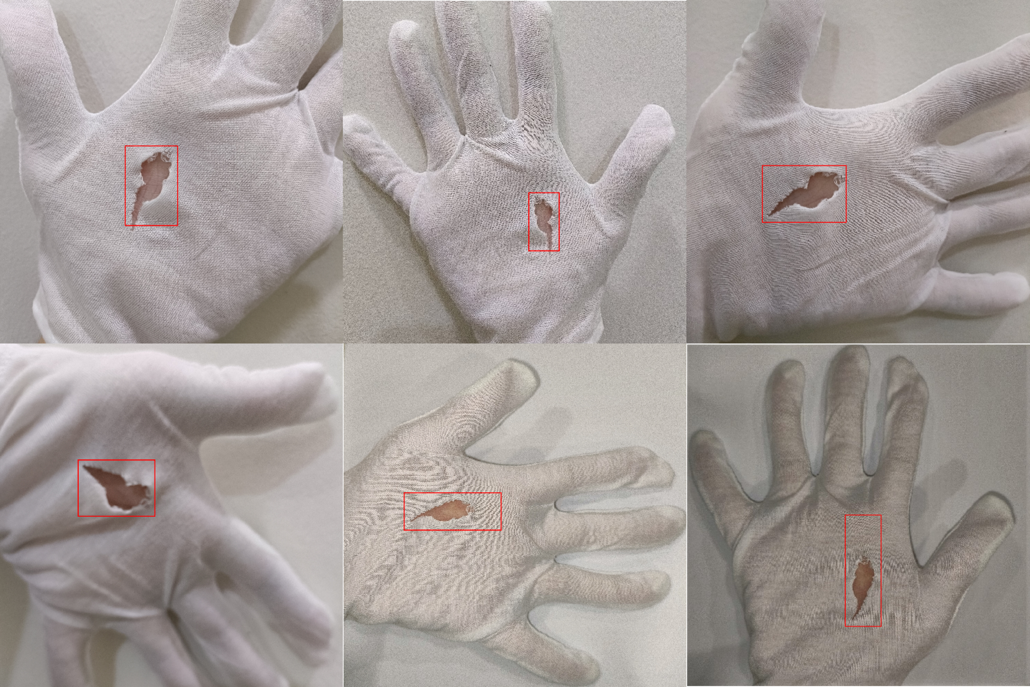

Figure : Cloth Glove Tearing Defect Detection.

## 4.3 (Foam Glove) Results by Boey Shu Wei (TP053979)

### 4.3.1 `Cutting` Defect

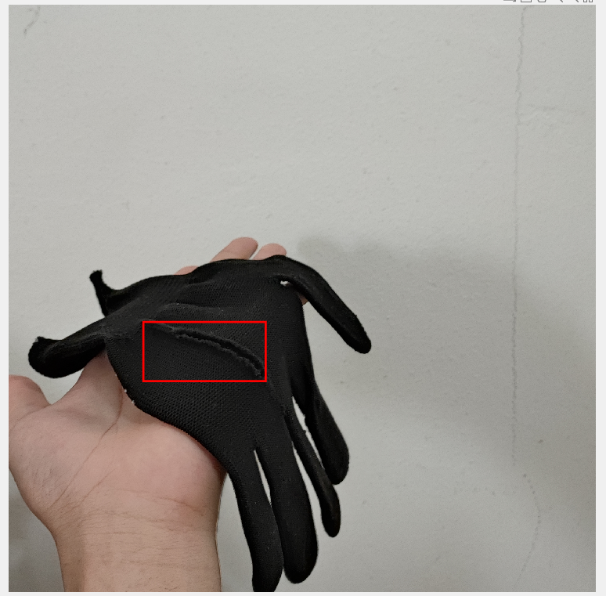

### 4.3.2 `Small Wrist Thorn Cut` Defect

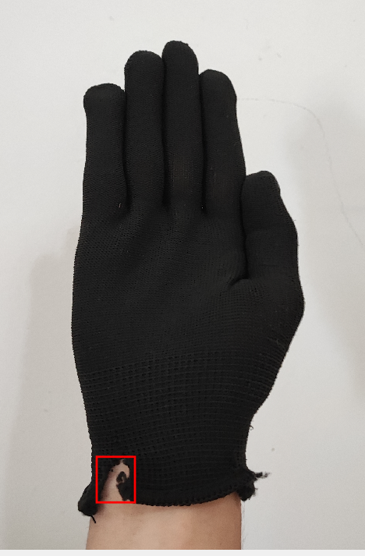

### 4.3.3 `Wrist Tearing` Defect

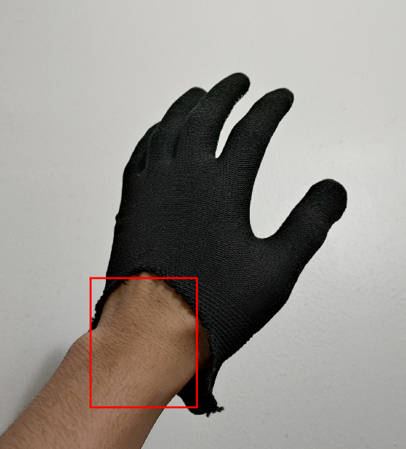

# 5.0 Description and Discussion on The Obtained Results

## 5.1 Discussion by Ng Eng Siong (TP055095)

For `Missing Finger` detection, the first part of the code transforms the input image to HSV color space and extracts the saturation channel. It then applies a threshold to isolate the glove and finger region, removes small pixels that are too small, and removes noise. It then applies Otsu Threshold Method for the glove region, removes noise of the glove region, and removes small pixels that are too small. The defect region is obtained using the difference between the isolated region and the glove region, and then the noise and small white regions are filtered out. The defect region is smoothened, labelled, and bounding boxes are created for the detected finger defects. In the second part, it checks the skin coverage of the detected defects by extracting the image from the bounding box, resizing the mask image to have the same size as the input image, replicating the mask image across the additional channels of the input image, inverting the defect mask, and thresholding the HSV image to create a binary mask. Finally, it checks if the detected defects are actual finger defects by checking the skin coverage of the defects.

In the case of the `Missing Finger` defect result, a bounding box has been generated around the missing finger in the image. Therefore, the missing finger in the glove has been successfully detected and isolated from the rest of the image. However, the robustness of the detection algorithm is still debatable because if a different skin coloured individual wears the glove and uses it as a test image, the result would most probably be a failure because the colour range for `skinCoverage` in the system is relatively fixed.

For the `Hole` and `Stained and Dirty` defect, The code first transforms the input image from RGB to HSV color space, extracts the saturation channel, applies a threshold to isolate the glove region, removes noise and small pixels, and erodes the glove region. Then, the code applies a single threshold segmentation and masks out the glove region. After that, it smooths the possible defect regions using imclose() and calculates the bounding box of possible defects. The code then removes extra small or big defects and displays the stained/dirt defect pre-processing image.

For each detected possible defect, the code extracts the image from the bounding box, replicates the mask image across the additional channels of the input image, and applies thresholding on the hue channel to identify blue pixels. Finally, **the code counts the number of blue pixels to determine whether the defect is a dirty/stain or a hole.**

In the case of the `Stained and Dirty` defect result, a bounding box has been generated around the area with any stain or dirtied surface on the glove. Therefore, the stained/dirty defect detection has been successfully identified and isolated from the rest of the image. However, one thing to note is that the stain on the glove be very visible, else the system would not fully detect the whole defect. This is because it still requires some more tweaking of the algorithm.

In the case of the `Hole` defect result, bounding boxes were also generated around the holes in the gloves. Therefore, it can be said that the holes in the gloves have been successfully detected and isolated from the rest of the image using the bounding box. However, the detection system would have trouble detecting larger holes as the threshold in the system for it to consider it a `hole` defect is relatively small. It would require some extra tweaking to ensure being able to detect larger holes on gloves. There is also another issue where if a different skin colour is under the glove, the system would have trouble detecting the hole and would consider it as a stain/dirtied defect because the colour range for the `skinCoverage` is fixed.

## 5.2 Discussion by Wong Horng Woei (TP055241

By starting the cloth glove type defect detection, data preparation is done by using glove that is made of cloth and take numerous pictures of the cloth glove with different defects such as open seam, unravelled seam, tearing. The pictures taken is used as testing image for defect detection. Then the images will be used for cloth glove identification, the image pre-processing section shows the performance of the entropy filter in enhancing the texture features of the image, and the effectiveness of the morphological closing and hole-filling operations in removing noise and filling gaps in the binary image. A binary image is created using a threshold of 0.5, where pixel values above the threshold are set to white and those below are set to black. Objects in the binary image with an area less than 2000 pixels are removed. A morphological closing operation is performed on the binary image using a 9x9 neighbourhood of ones to merge adjacent white regions and fill gaps in the image. Finally, the holes in the closed binary image are filled and the number of non-zero pixels in the resulting mask is counted to determine the number of cloth regions in the original image.

After detecting the cloth glove, the actual “Open Seam” defect detection image processing starts. The image pre-processing steps involve converting the RGB input image to the HSV colour space to extract the hue, saturation, and value channels. The hue channel is threshold to identify regions with hues that correspond to red, and the boundary regions of the resulting binary image are removed using a morphological operation called “clear border”. Erosion and dilation operations are performed on the binary image to remove noise and smooth the edges of the remaining regions. Finally, the connected components in the binary image are labelled, and the bounding boxes for each component are extracted and displayed around the corresponding regions in the input image. These pre-processing steps help to enhance the red regions in the image and make them easier to detect. The obtained detection results can be discussed in terms of the accuracy of the bounding boxes, the number of detected regions, and the overall effectiveness of the algorithm in detecting red cloth in the input image.

The obtained result of detecting all open seams with accurately surrounded bounding boxes indicates that the algorithm is effective in identifying the open seams in the input image. It can be concluded that the image processing pipeline implemented in this code is suitable for detecting open seams in similar images. It is also worth noting that the detection is not sensitive to environmental changes as the one of the images was taken with different background. However, it is also important to note that this algorithm's performance may vary depending on the quality of the input image and the specific characteristics of the open seams. Therefore, further testing and optimization may be required to ensure the algorithm's robustness and accuracy in real-world scenarios.

The “Unravelled Seam” defect detection algorithm first converts the input image from RGB to HSV colour space and separates the hue, saturation, and value channels. The saturation channel is then binarized using Otsu's method and inverted. The inverted saturation image is then eroded and dilated to remove small noise and fill gaps in the image. Next, the hue channel is binarized and combined with the processed saturation image using logical AND. The resulting image is then eroded and dilated again before objects touching the border are removed. Finally, the connected components in the binary image are labelled and bounding boxes are obtained. The obtained detection results show that the algorithm can detect the “Unravelled Seam” defect accurately with a single bounding box surrounding the defect. Overall, the obtained results show effectiveness in detecting “Unravelled Seam” defects, the bounding boxes are surrounding the defects correctly. However, the algorithm is designed to detect only the first defect it encounters, which may limit its usefulness in detecting multiple defects in a single image.

The image pre-processing progress involves several steps to detect “Tearing” defects in an image. First, the RGB image is converted to the HSV colour space to separate the hue, saturation, and value channels. Then, a binary mask is created to segment out pixels with low or high saturation, and the regions with moderate saturation are kept by inverting the saturation mask. Next, objects touching the image border are removed, and the mask is dilated and eroded to connect nearby pixels and separate overlapping regions. Finally, the connected components in the mask are labelled, and the bounding box of the largest region is obtained. The obtained result shows that all “Tearing” defects are accurately detected, and the bounding boxes are surrounding the defects correctly. The pre-processing steps are crucial for accurate detection, and the obtained results show that the algorithm is performing well.

## 5.3 Discussion by Boey Shu Wei (TP053979)

The overall detections are done in a flow like this: trying to get the standalone defection out with two image subtraction, and then plot the connected components out with different criteria. Since the glove are in black, all images are worked in 2D dimension.

For the cutting defection in section 4.3.1, we first get a binary version of the image, with a series of testing to find the perfect balanced threshold value and noise removal, then an erosion to remove bigger plots, followed up with a dilation to compensate the thin cutting line cause by erosion. In the end, a binary glove image with outline and a cut line in the middle has formed. To remove the outline and crop the cut line out, I first create another binary of the glove again with bwperim(), to get the outline only, then thicken the outline with dilation. Then I apply the outline onto first image to make a binary image that the cut line is obvious enough for MATLAB to detect, the detection criteria I used is to compare the longest continuous line in the image.

For the second defection, which is seeking small thorn cut on the wrist. The first step is to get a clean binary image of the glove, and then I crack the thorn cut bigger to get a more obvious appearance, this is for easier detection and avoid being covered later. Then I create another binary image with the crack sealed and subtract both of them to crop out the thorn cut. Then detect it with a criterion of the largest blob in the image.

For the wrist tearing, again I make the image into binary form. Then I use edge detection to get the outline of the image. After that I fill the outline image with imfill() function, to create a flat white glove object. Since the tearing is big, I seal the fingers first with imclose(), and then remove any possible hand line with erosion and dilation, to isolate the glove part. Then I seal the tearing part again with a larger parameter than in sealing fingers and subtract the before and after images to find the largest blob in the picture, which indicates the tear.

# 6.0 Critical Comments, Analysis and Future Work Direction

Based on the discussion, there are a few critical comments that can be made regarding the detection system. Firstly, the system's robustness is limited by the fixed range of skin colours that it can detect. This means that if a person with a skin colour outside of this range wears the gloves, the detection system may not work correctly. Additionally, the system's ability to detect larger holes in gloves is limited due to the threshold used to classify them as a "hole" defect. This could be problematic if larger holes are present in the gloves, as they could go undetected. Next, the system's ability to detect stains or dirt on gloves is limited by the visibility of the stain or dirt, which could cause some defects to go unnoticed. Additionally, the “Open Seam”, “Unravelled Seam”, "Tearing" defect detection have its limitation that it is designed to detect only one defect, this may limit its usefulness in detecting multiple defects in a single image.

In terms of future work direction, it can be said that the detection system has some limitations that could be addressed to improve its overall performance. One potential future work direction would be to improve the system's robustness by training it on a more diverse skin colour. This could help the system detect defects on a wider range of people and improve its overall performance. Additionally, the system's ability to detect larger holes in gloves could be improved by adjusting the threshold used to classify them as a "hole" defect. This could be done by analysing a larger dataset of gloves with various hole sizes and adjusting the threshold accordingly. Furthermore, the system's ability to detect stains or dirt on gloves could be improved by using more advanced image processing techniques to enhance the visibility of stains or dirt on gloves as demonstrated by (Chen & Sun, 2016). This could help the system detect more subtle defects that might otherwise go unnoticed. Moreover, the future work in cloth glove defect detection could focus on developing more robust algorithms that can handle a wide range of image qualities and different types of defects. The algorithms that can detect multiple defects in a single image would be more useful in practical applications. Finally, using deep learning techniques such as convolutional neural networks (CNNs) could improve the robustness and accuracy of defect detection algorithms as demonstrated by (Fusaomi, et al., 2019)

# 7.0 Conclusion

It has been a great opportunity for the group members to learn about image processing, computer vision, and pattern recognition in practise through this project. The project's objectives included designing and implementing a piece of software that uses appropriate techniques to process images for computer vision and pattern recognition for a specific problem domain, as well as choosing between potential solutions based on a logical, critical assessment of the requirements of a given issue.

Through the course of this project, we have accomplished our goals by developing a Gloves Defect Detection (GDD) system that can identify different types of defects in at least three types of gloves. We have surveyed and selected candidate techniques, including segmentation, feature extraction methods, and provided justification for our choices. We have also developed a GUI to display the types of defects identified and tested the system using various test images.

While developing the GDD system, we encountered several challenges, such as selecting appropriate techniques for each stage of the image processing pipeline, optimizing the parameters for each algorithm, and dealing with noise and other environmental factors that could affect the accuracy of the system. However, we have overcome these challenges by working collaboratively, conducting thorough research, and applying critical thinking and problem-solving skills.

To sum it up, this project has been an enriching and rewarding experience that has equipped us with practical skills and knowledge that can be applied to real-world applications. We have learned how to design and implement a complex image processing system and how to critically evaluate and justify our choices. We have also developed teamwork, communication, and project management skills, which will be valuable in our future careers as engineers and researchers.

# References

Chen, Q., & Sun, X. (2016). Defects Detecting of Gloves Based on Machine Vision. *Proceedings of The 2016 IEEE International Conference on Real-time Computing and Robotics (RCAR)*, 169-173.

Fusaomi, N., Tokuno, K., Mitarai, K., Otsuka, A., Ikeda, T., Ochi, H., . . . Habib, M. K. (2019). Defect detection method using deep convolutional neural network,. *Artifcial Life and Robotics*, 512-519.

Izmiran. (n.d.). *Image Processing Toolbox User's Guide imerode*. Retrieved from izmiran: http://matlab.izmiran.ru/help/toolbox/images/imerode.html

MathWorks. (21 March, 2023). *bwareaopen*. Retrieved from MathWorks: https://www.mathworks.com/help/images/ref/bwareaopen.html?s_tid=doc_ta

MathWorks. (21 March, 2023). *graytresh*. Retrieved from MathWorks: https://www.mathworks.com/help/images/ref/graythresh.html?s_tid=doc_ta

MathWorks. (21 March, 2023). *imbinarize*. Retrieved from MathWorks: https://www.mathworks.com/help/images/ref/imbinarize.html

MathWorks. (21 March, 2023). *imclose*. Retrieved from MathWorks: https://www.mathworks.com/help/images/ref/imclose.html?s_tid=doc_ta

MathWorks. (21 March, 2023). *imcrop*. Retrieved from MathWorks: https://www.mathworks.com/help/images/ref/imcrop.html?s_tid=doc_ta

MathWorks. (21 March, 2023). *imdilate*. Retrieved from MathWorks: https://www.mathworks.com/help/images/ref/imdilate.html?s_tid=doc_ta

MathWorks. (21 March, 2023). *imfill*. Retrieved from MathWorks: https://www.mathworks.com/help/images/ref/imfill.html?s_tid=doc_ta

MathWorks. (21 March, 2023). *medfilt2*. Retrieved from MathWorks: https://www.mathworks.com/help/images/ref/medfilt2.html?s_tid=doc_ta

MathWorks. (21 March, 2023). *rgb2hsv*. Retrieved from MathWorks: https://www.mathworks.com/help/matlab/ref/rgb2hsv.html

MathWorks. (21 March, 2023). *strel*. Retrieved from MathWorks: https://www.mathworks.com/help/images/ref/strel.html?s_tid=doc_ta

MathWorks. (n.d.). *bwconncomp*. Retrieved from MathWorks: https://www.mathworks.com/help/images/ref/bwconncomp.html

MathWorks. (n.d.). *bwperim*. Retrieved from MathWorks: https://www.mathworks.com/help/images/ref/bwperim.html

MathWorks. (n.d.). *edge*. Retrieved from MathWorks: https://www.mathworks.com/help/images/ref/edge.html

Parekh, R. (2021). *Fundamentals of Image, Audio, and Video Processing Using MATLAB With Applications to Pattern Recognition.* Florida: CRC Press.

Ren, Z., Fang, F., Yan, N., & Wu, Y. (2021). https://doi.org/10.1007/s40684-021-00343-6. *International Journal of Precision Engineering and Manufacturing-Green Technology*, 661-691.